Project Design Phase-II

Technology Stack (Architecture & Stack

Date | 19-feb-2026
Team ID | LTVIP2026TMIDS64562
Project Name | Smart Sorting: Healthy vs Rotten Fruits & Vegetables Detection using Deep Learning
Maximum Marks | 4 Marks

Technical Architecture:
The Deliverable shall include the architectural diagram as below and the information as per the table1 & table 2
Example: Order processing during pandemics for offline mode
Reference: https://developer.ibm.com/patterns/ai-powered-backend-system-for-order-processing-during-pandemics/

Guidelines:
Include all the processes (As an application logic / Technology Block)
Provide infrastructural demarcation (Local / Cloud)
Indicate external interfaces (third party API’s etc.)
Indicate Data Storage components / services
Indicate interface to machine learning models (if applicable)
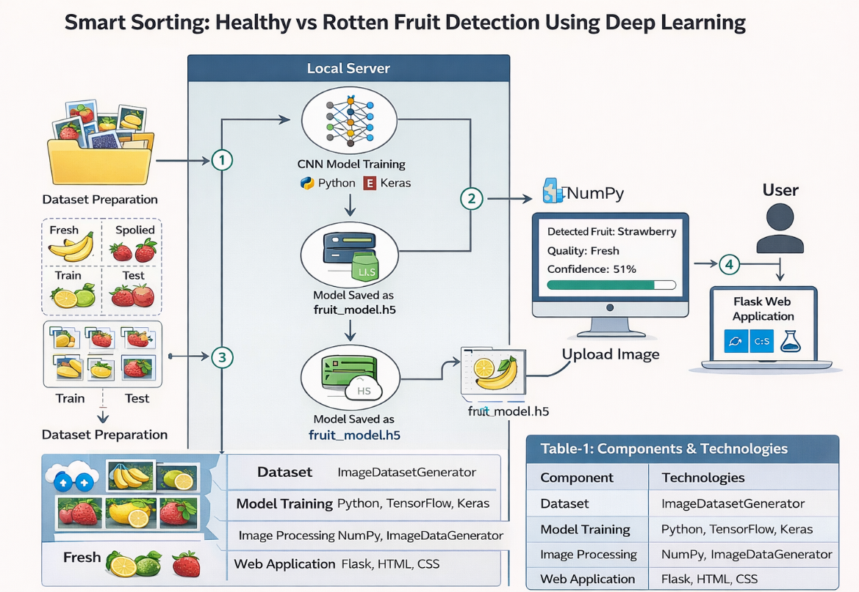

Table-1 : Components & Technologies:

S.No | Component | Description | Technology
1 | User Interface | Web-based image upload interface | HTML, CSS
2 | Application Logic-1 | Image preprocessing (resize, normalization) | Python, NumPy
3 | Application Logic-2 | CNN model prediction | TensorFlow, Keras
4 | Application Logic-3 | Result extraction (fruit name + quality + confidence) | Python
5 | Database | Not required (image-based prediction system) | —
6 | Cloud Database | Not used (Optional future scope) | —
7 | File Storage | Dataset images and trained model storage | Local File System
8 | External API-1 | Not used in current version | —
9 | External API-2 | Not used in current version | —
10 | Machine Learning Model | Detect fruit type & classify fresh/spoiled | CNN Model (TensorFlow/Keras)
11 | Infrastructure (Server / Cloud) | Application deployed on local system | Local Server (Flask)

Table-2: Application Characteristics:

S.No | Characteristics | Description | Technology
1 | Open-Source Frameworks | All tools used are open-source | Python, TensorFlow, Flask
2 | Security Implementations | Input validation for image upload, restricted file types | Flask Security Controls
3 | Scalable Architecture | 3-Tier Architecture allows easy scaling and cloud deployment | Flask + Cloud Deployment
4 | Availability | Can be deployed on cloud server for 24/7 availability | AWS / IBM Cloud (Optional)
5 | Performance | CNN optimized with image resizing (224×224), data augmentation | TensorFlow Optimization

